Project Documentation
AI-Powered Movie Recommendation System 🎬✨
This document presents the final architecture, datasets, and methodologies used in the development of the AI-Powered Movie Recommendation System. The project evaluates multiple collaborative filtering techniques and integrates a Large Language Model (LLM) to enhance personalization and user engagement.
1. Business Problem 📈
Modern movie streaming platforms face a major challenge: keeping users engaged and retaining them over time. With an overwhelming amount of available content, users rely heavily on recommendation systems to discover relevant movies efficiently.
This project aims to solve this problem by building a recommendation engine capable of delivering highly personalized movie suggestions, achieving the following business objectives:
- Increase User Satisfaction
Personalized recommendations encourage users to explore content that matches their preferences.
- Boost Engagement and Revenue
Better recommendations lead to longer sessions, increased viewing frequency, and higher conversion rates.
- Strategic Differentiation
A strong recommendation system enhances the overall customer experience and differentiates the platform from competitors.
Additionally, integrating a Large Language Model (LLM) to generate personalized recommendation messages creates a more human-like experience, making users feel personally valued rather than algorithmically targeted.

2. Data Sets 💾
The project utilizes the MovieLens 1M dataset, a widely used benchmark dataset for recommendation systems.
- Users: 6,040
- Movies: ~3,900
- Ratings: ~1,000,000

Dataset | File | Attributes | Role in Analysis
Users | users.dat | UserID, Gender, Age, Occupation, Zip-code | Used to enhance personalization
Ratings | ratings.dat | UserID, MovieID, Rating, Timestamp | Used to construct the User-Item Matrix for training the collaborative filtering model
Movies | movies.dat | MovieID, Title, Genres | Used for interpreting results and presenting human-readable movie recommendations

3. Recommendation Methods Implemented and Tested 🧪
To identify the most effective solution, several collaborative filtering approaches were implemented, evaluated, and compared. Each method offered different trade-offs between accuracy, scalability, and execution time.
CF Approach | Methodology | Strengths | Limitations | Outcome
Cluster-Based | Grouping users by similarity | High speed | Over-generalization | Fast but poor quality
User-Based (Cosine) | Similarity via cosine patterns | Balanced accuracy/speed | Data sparsity | Selected Model
User-Based (Pearson) | Linear correlation of ratings | Adjusts for scale | Very slow; low precision | Rejected
Hybrid (Heatmap) | CF + Clustering + Visuals | High interpretability | Hard to automate | For analysis only
Hybrid (Demographic) | CF + User profiles | Solves cold-start | High complexity | Improved relevance
Item-Based | Item-to-item similarity | Stable for fixed catalogs | Long execution time | Rejected

4. Final Data Science Architecture 🧠
A. Core Recommendation Engine
User-Based Collaborative Filtering (Cosine Similarity) 🤝
After evaluating all six approaches, User-Based Collaborative Filtering using Cosine Similarity was selected as the final model due to its superior balance of accuracy and efficiency.
Description of the approach:
- Similarity Metric: Cosine Similarity on the User–Item Matrix
- Neighbor Selection: Users with the most similar rating vectors
- Performance evaluation: Precision@10, Recall@10, F1@10 using stratified 5-fold cross-validation
- Recommendation Logic:
Movies highly rated by similar users are recommended to the target user, excluding previously rated movies

🔍 Evaluation Metrics Summary
This evaluation report summarizes and compares the performance of different Collaborative Filtering approaches for the AI-Powered Movie Recommendations System. It includes a performance table and a recommendation based on key evaluation metrics: Precision@10, Recall@10, and F1-Score@10 (for top 10 recommendations).
Metric | Description | Goal
Precision@10 | Predictive accuracy: Proportion of top-10 recommended movies that are relevant | Minimize not relevant recommendations
Recall@10 | Sensitivity: Proportion of relevant movies retrieved in top-10 recommendations | Maximize coverage of user interests
F1-Score@10 | Harmonic mean of Precision@10 and Recall@10 | Quantify the harmonic trade-off between predictive precision and retrieval sensitivity.

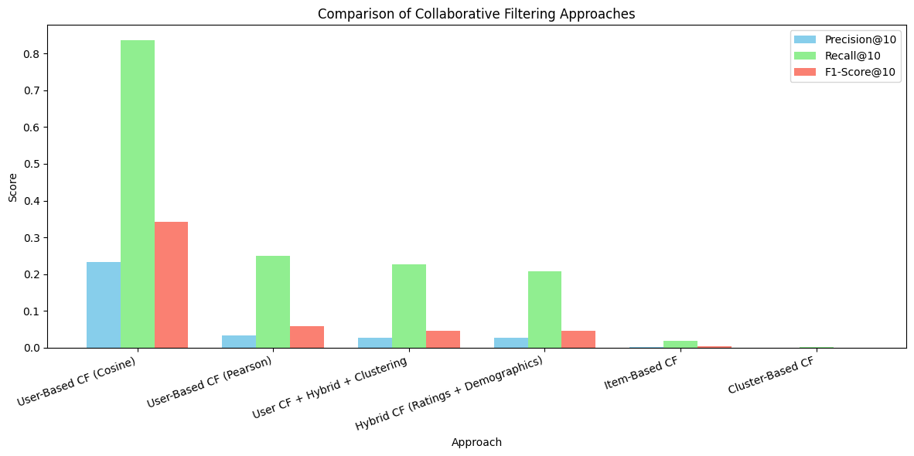
Approach | Precision@10 | Recall@10 | F1-Score@10 | Execution Time
User-Based CF (Cosine) | 0.2325 | 0.8358 | 0.3414 | 143 sec (27 sec per fold)
User-Based CF (Pearson) | 0.0334 | 0.2498 | 0.0575 | ~2.13 hrs
Cluster-Based CF | 0.0002 | 0.0023 | 0.0004 | 252 sec (50 sec per fold)
Item-Based CF | 0.0018 | 0.0175 | 0.0033 | ~4.4 hrs
User CF + Hybrid + Clustering | 0.0265 | 0.2258 | 0.0468 | ~9 hrs
Hybrid CF (Ratings + Demographics) | 0.0268 | 0.2071 | 0.0463 | ~1 hr

Conclusion:
User-Based CF with Cosine Similarity achieved the highest overall performance while remaining computationally efficient.
B. Personalization Layer: Large Language Model (LLM) Integration 💬
To enhance the user experience and make the recommendations feel more personalized, a pre-trained Large Language Model (LLM) is integrated into the final recommendation pipeline.
Description of the approach:
- Purpose: Generate friendly, personalized recommendation messages
- Personalized Messaging: The pre-trained LLM generates a personalized, natural-sounding message to introduce the list of recommended movies.
- Input Data: The recommended movie titles, along with the user's name and demographic information, are provided to the LLM via an API (Ollama).
- Prompt Engineering: The LLM is directed using a carefully designed prompts ensure engaging and relevant messaging
Example Prompt:
"You are a friendly and enthusiastic movie recommender for our platform, 'WatchIt'. A user named [User Name] is a [Job] and is [Age]. Based on their tastes, we think they'll love these movies: [Movie 1], [Movie 2], and [Movie 3]. Write a short, exciting, and personalized message (2–3 sentences) introducing these recommendations."
- Goal: This layer transforms algorithmic output into human-centered communication, increasing trust, engagement, and perceived value.

6. End-to-End Workflow 🚀
- Raw MovieLens data ingestion
- Data cleaning and preprocessing
- User–Item Matrix construction
- Collaborative filtering model execution and evaluation
- Recommendation generation
- Personalized message creation using LLM
- Final recommendation delivery to the user via FastAPI

Resources:
- MovieLens dataset: https://www.kaggle.com/datasets/odedgolden/movielens-1m-dataset
- GitHub repository with the full project code: GitHub - AI Movie Recommender

